**Instructions on how to use the refrigerator properly and effectively**

*If you know how to use the refrigerator properly, your family's monthly electricity bill will be greatly reduced. In addition to choosing to buy refrigerators equipped with Inverter technology for optimal power saving, you need to "pocket" some tips to use the refrigerator effectively to extend the life, increase the durability of the device.*

**Place the refrigerator in a cool, damp place**

The temperature around the refrigerator position affects the heat dissipation and power consumption. Therefore, the user should place the refrigerator in a well-ventilated place, restricting it to a narrow corner of the house. To ensure heat loss, the back and sides of the refrigerator's side must be at least 10cm away from the wall, because the cooling cable system behind the cabinet needs a cool air to cool, otherwise the refrigerator is very power-consuming and fast. level.

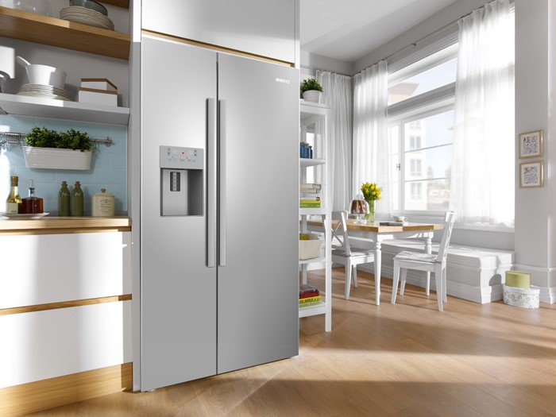

*Need to put the refrigerator in a well-ventilated place*

At the same time, the location of the refrigerator should avoid heat sources, do not place the refrigerator next to the stove, kitchen or window with direct sunlight.

**2. Check the inhalation door**

After a long time, the rubber seals in the back door can be damaged, making the refrigerant cabinet much cooler. Tips to check: clamp a sheet of money into the slot, if it is easy to pull money to learn the gap, you need to replace the rubber roll.

**3. Limit on / off the refrigerator**

Every time it restarts, the refrigerator needs a large amount of power. Therefore, do not turn on / off the refrigerator frequently, do not plug in the refrigerator and the outlet with any other device.

If the refrigerator is not used for a long time, it is necessary to disconnect the power, but clean the food in the cabinet and cover it with dust.

**4. Limit the opening / closing of the refrigerator**

Each time the door is opened, cold air is evaporated a lot, requiring a more expensive refrigerator to cool from the beginning. So do not open the fridge for too long and remember to close the refrigerator closely.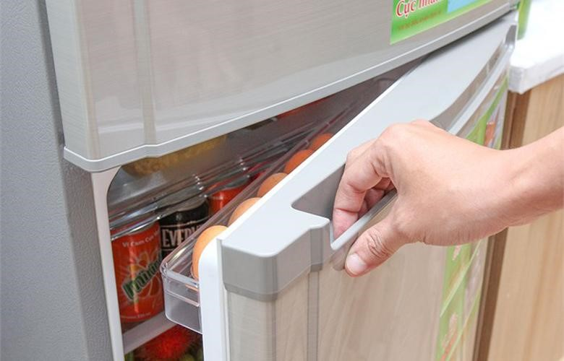

*It is advisable to limit**the opening / closing of the refrigerator to reduce the damage of rubber gasket and to reduce the loss of cold air*

**5. Do not leave the refrigerator too empty or too much**

Refrigerators filled with food and drinks will cool faster than empty refrigerators. If you do not have many containers in the refrigerator, you can put in a few bottles of water bottles.

However, if storing too much food will prevent cold air circulation, leading to less efficient cooling.

**6. Adjust the temperature accordingly**

The temperature in the refrigerator needs to be consistent with the weather, so the temperature should not be fixed for a long time. The temperature at 5 consumes a lot of energy. On hot days, you should increase the temperature to 4. In contrast, cold days you can adjust the cold to level 3.

**7. Store food science**

One way to use the refrigerator effectively housewives should pay attention to keeping things inside neatly, creating a reasonable gap so that cold air flow easily and limit electricity consumption. Do not put hot food in the refrigerator immediately, let it cool completely. Food layout in compartments:

Frozen ice cubes: Store fresh food (meat, fish, seafood), make cool ice cubes, ice cream or yogurt.

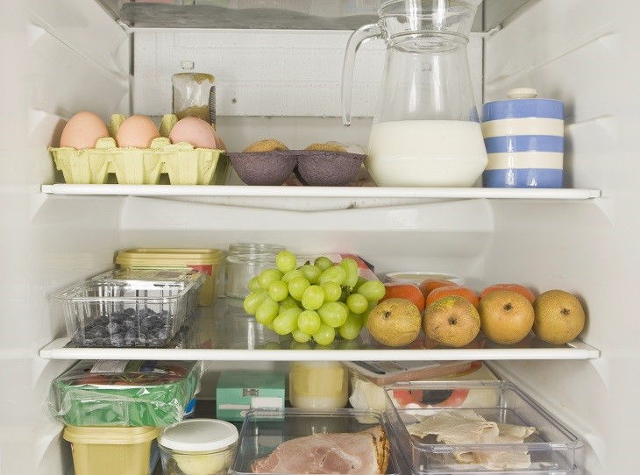Refrigerator for refrigerator: Cabinet door (only for dry food or spices, sauce), top shelf (leftovers, drinks or instant food in the cabinet), the lower shelves (set eggs, milk, meat or seafood that you want to use quickly or thawed, cabinets (designed to help maintain moisture ontent suitable for vegetables, fruits, vegetables)

*Arrange neat and tidy food to avoid unexpected damage*

**8. Clean the refrigerator clean**

The use of simple efficient refrigerators needs to be done regularly to clean the refrigerator to limit the growth of mold and bacteria. We need to clean 1-2 times a month or whenever the compartments are dirty. Note to clean the rubber edge at the opening and closing door to make the door more closed, to avoid cold air escaping, which consumes power.